#longmonsterlove Social Media Kit

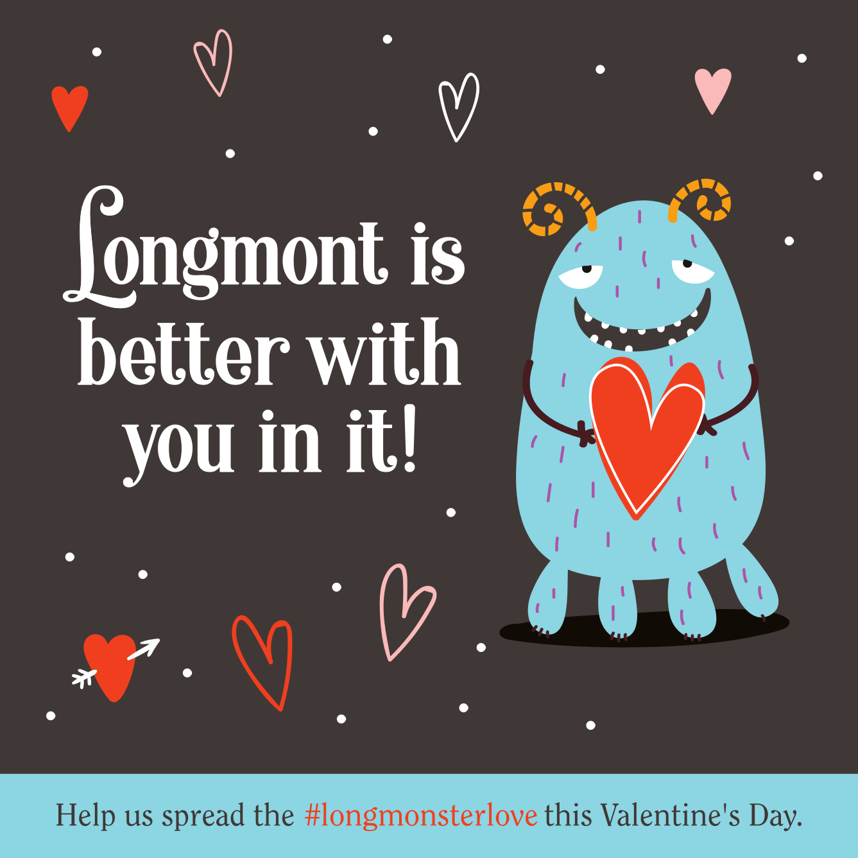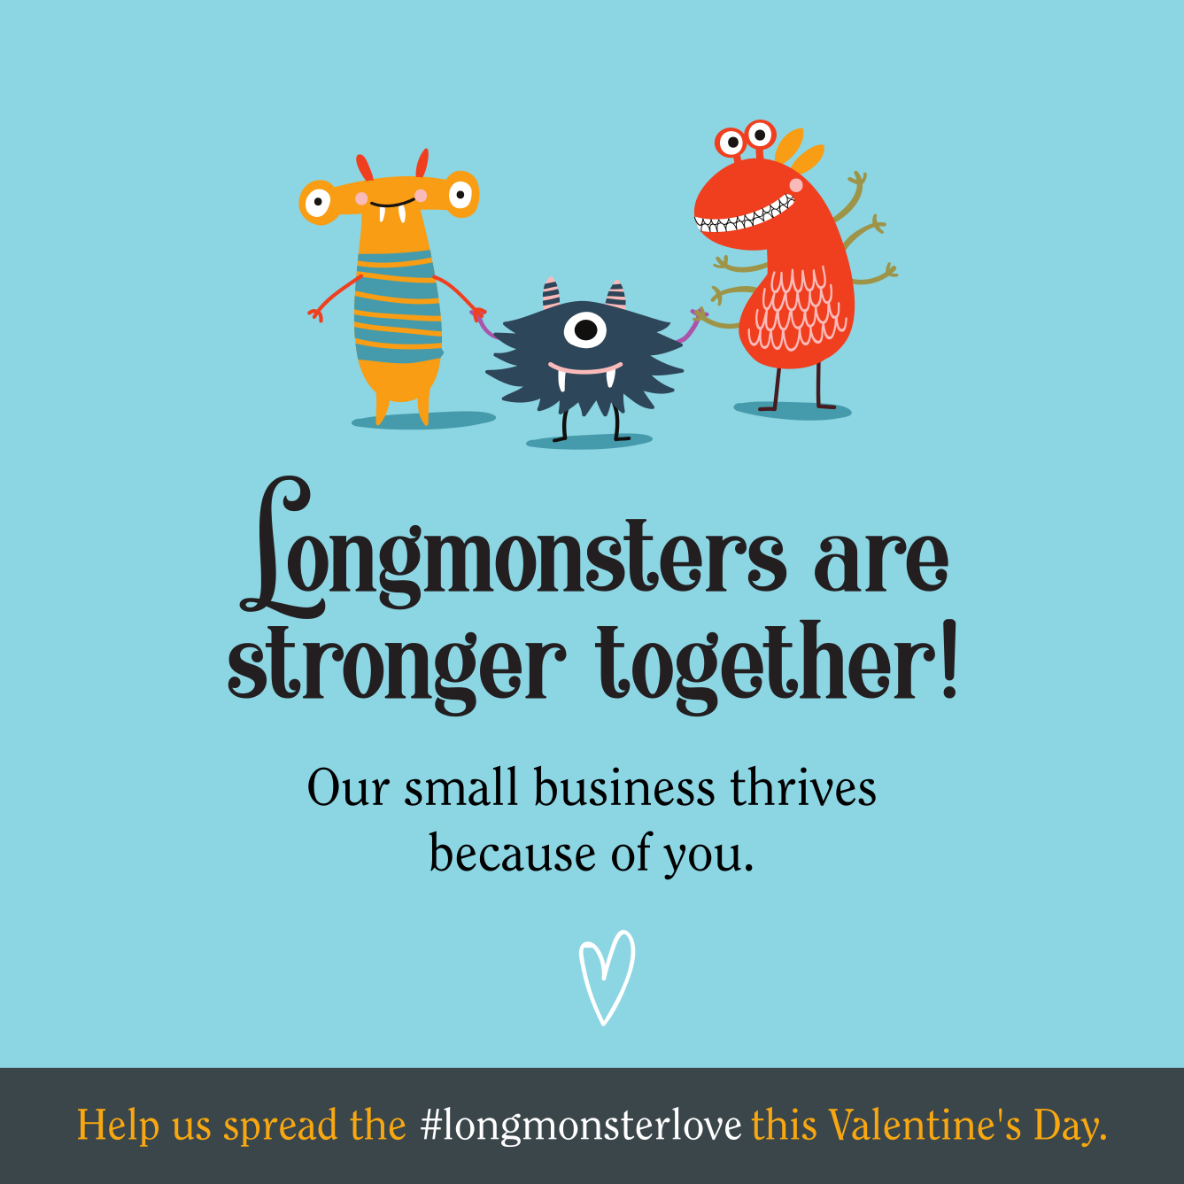

How to share your participation on social media and qualify for the Prize Pack:

- Download the above images here and here

- Share one or both images to social media in a post by copying & pasting provided language below or feel free to craft your own! **Don’t forget to include the hashtag #longmonsterlove

- 1 Post = 1 Entry into the prize drawing (No Limits)
Ex. 2 entries would be counted for 1 post on Facebook and 1 on Instagram

- Post must include hashtag #longmonsterlove so that we can track the entries on social media.

- Continue to share to Instagram and Facebook stories throughout the campaign and tag @bricksretail so we can mark your entry (Hashtags don’t work the same in stories so a tag is needed for us to track your entries.)

- Each story share is also an entry, so share away!

Giveaway Details:
A winner will be chosen at random on February 28, 2022- So the more entries, the more chances! Good luck! Prize pack valued at over $500 includes:
- A Local Love gift box from Bricks Retail
- A beanie, glass, and two growler fills from 300 Suns Brewing, and
- A mini headshot or product-based photoshoot with Branded Beet

Participating Businesses social media caption content:

For Instagram:
We are so excited to join the #longmonsterlove campaign and show our customers how much they mean to us. Shopping local is a choice and we’re so very grateful for this community for continuing to shop with us all throughout the year. Come in now through Feb 14th to grab a special Valentine’s Card from us to you, and share in the love of Longmont!

**If you choose to include an extra bounce back coupon or treat with your card, include that info here.
–

(Consider tagging @bricksretail @300sunsbrewing @brandedbeet as the sponsoring businesses- Not required but much appreciated! **Tagging in stories is important though to count your entry!)

For Facebook:
We are so excited to join the #longmonsterlove campaign and show our customers how much they mean to us. Shopping local is a choice and we’re so very grateful for this community for continuing to shop with us all throughout the year. Come in now through Feb 14th to grab a special Valentine’s Card from us to you, and share in the love of Longmont!

**If you choose to include an extra bounce back coupon or treat with your card, include that info here.

To learn more click here: (Link to Website)
–

(Consider tagging @bricksretail @300sunsbrewing @brandedbeet as the sponsoring businesses- Not required but much appreciated! **Tagging in stories is important though to count your entry!)

For Twitter:
We want to show our customers how much we appreciate them all year long so we’ve joined the #longmonsterlove campaign! Come on in and grab a special Valentine’s Card from us to you!

